- Sampurn(e)arth Environment Solutions - From Mumbai to Berkeley: A Social Enterprise Takes the World Stage
Sampurn(e)arth Environment Solutions, founded in 2012 by TISS Social Entrepreneurship graduates Debartha Banerjee, Ritvik Rao and Jayanth N., emerged from a simple but powerful idea: transform waste from a problem into an economic and social resource. Incubated through the TISS incubation ecosystem, the venture developed a decentralised, end-to-end waste management model that combined environmental sustainability with the dignity and livelihoods of informal waste workers.
The venture went on to become the first Indian social enterprise to win the prestigious Global Social Venture Competition (GSVC) at UC Berkeley in 2014, competing against hundreds of teams globally. In 2017, Sampurn(e)arth was recognised as the Best Social Enterprise at the National Entrepreneurship Awards, instituted by the Government of India. Its founders also received recognition including Forbes 30 Under 30 Asia and the Mumbai Heroes award.
From serving early clients to working with major organisations including Tata Group companies, EY, Coca-Cola, Unilever and BARC, Sampurn(e)arth demonstrated how a socially driven idea could evolve into a credible, market-based enterprise with national relevance. For TIF, Sampurn(e)arth is a powerful example of how incubation can convert purpose into a scalable enterprise—and a local idea into an internationally recognised social innovation.



- Even Cargo - Delivering More Than Parcels: Delivering Possibility
Even Cargo, founded by TISS alumnus Yogesh Kumar, began with a simple but radical idea: women should have equal access to economic opportunities, including in sectors traditionally dominated by men. Incubated at TISS, the venture trained women from marginalised communities to become delivery professionals, creating dignified livelihoods while challenging deeply entrenched gender stereotypes.
Earlier known as WEcab, Even Cargo won the Young Social Entrepreneur Award in 2015 in Singapore, an achievement explicitly recognised by TISS as one of the successes of its incubation programme. The venture went on to become India’s first women-only e-commerce logistics company, partnering with major platforms including Amazon and Flipkart.
Its impact grew from training and employing hundreds of women to creating a new category of work—the “delivery girl”—in an industry where such a role was virtually unheard of. By 2021, Even Cargo had trained over 600 women and provided direct employment to more than 350, while helping women gain financial and digital inclusion and greater confidence in occupying public spaces. For TIF, Even Cargo represents the power of incubation to turn a social challenge into a viable enterprise—and, in the process, challenge the very definition of what women can do.

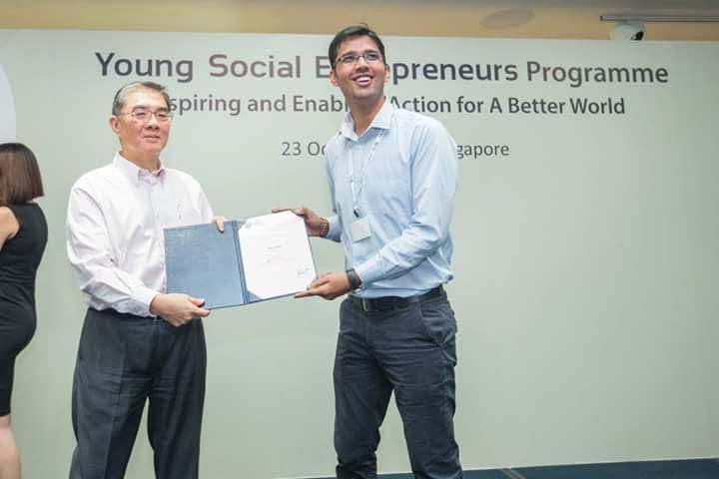

- Sahaytha Healthcare - A TIF-SPARSH fellow. 118 iterations. 5 prototypes. ₹1 crore investment on Shark Tank India.
Sahayatha Healthcare, founded by TISS Incube Foundation fellow from SPARSH Programme Sruthi Babu, began with a deeply human question: Why should a person who cannot walk also have to surrender their privacy and dignity? The Coimbatore-based venture developed an innovative wheelchair with an integrated commode and defecation-cleansing system, enabling people with severe mobility limitations to manage one of their most basic needs with greater independence.
The journey from idea to product involved 118 iterations and five prototypes, shaped through extensive feedback from doctors and users. In 2023, Sahayatha appeared on Shark Tank India, where Sruthi Babu secured ₹1 crore in investment and mentorship from four leading entrepreneurs—a milestone highlighted in TISS's Annual Report as a success of its incubation and mentoring ecosystem.
The venture has since moved beyond the prototype stage to supplying its wheelchairs to hospitals, NGOs and individual users, while building a product platform around mobility, hygiene and independence. Its journey has continued to attract recognition, including the CavinKare ChinniKrishnan Innovation Award 2025 and the Buimerc Nava DISHA Puraskaram 2025.
For TIF, Sahayatha is a powerful example of incubation turning empathy into engineering—and an idea addressing a deeply personal problem into an investable, nationally recognised healthcare innovation.


- Unexplored Bastar - He Came Back to Bastar to Change How the World Sees It
Unexplored Bastar began with a Facebook page and a conviction: Bastar deserved to be known for its forests, waterfalls, culture and people—not merely for the conflict that had defined its image. Jeet Singh Arya, a Bastar native who had spent nearly a decade in the corporate world, made the unconventional decision to leave it all behind and return home. In 2016, he transformed that idea into a social enterprise built around community-based and sustainable tourism.
But Jeet's ambition was never simply to bring tourists to Bastar. It was to make local communities participants—and beneficiaries—of tourism. Unexplored Bastar works with tribal and rural youth, guides, homestays, artisans and Self-Help Groups, creating livelihood opportunities while helping communities preserve and showcase their culture. Today, the organisation says its work impacts 1,800+ tribal and rural youth, with more than 1,000 local people trained in tourism and hospitality.
The model has earned national recognition. Unexplored Bastar was named Best Startup in the Tourism Sector at the National Entrepreneurship Awards 2019, instituted by the Government of India, and Jeet received the Indian Responsible Tourism Award 2023 from Outlook Traveller.
Perhaps the most powerful validation came when Chitrakote and Dudmaras villages in Bastar were recognised as Best Tourism Villages of India, a development Jeet describes as the culmination of years of work to put Bastar on India's tourism map.
For TIF, Jeet's journey represents something larger than the success of a tourism enterprise: it is the story of an entrepreneur who returned to his homeland, challenged a powerful stereotype, and turned tourism into an instrument for dignity, livelihoods and community-led development.
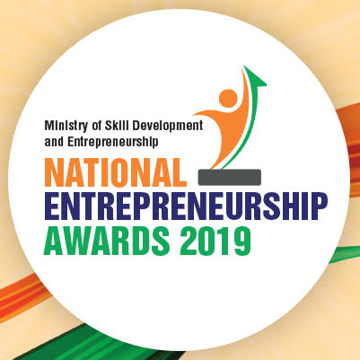
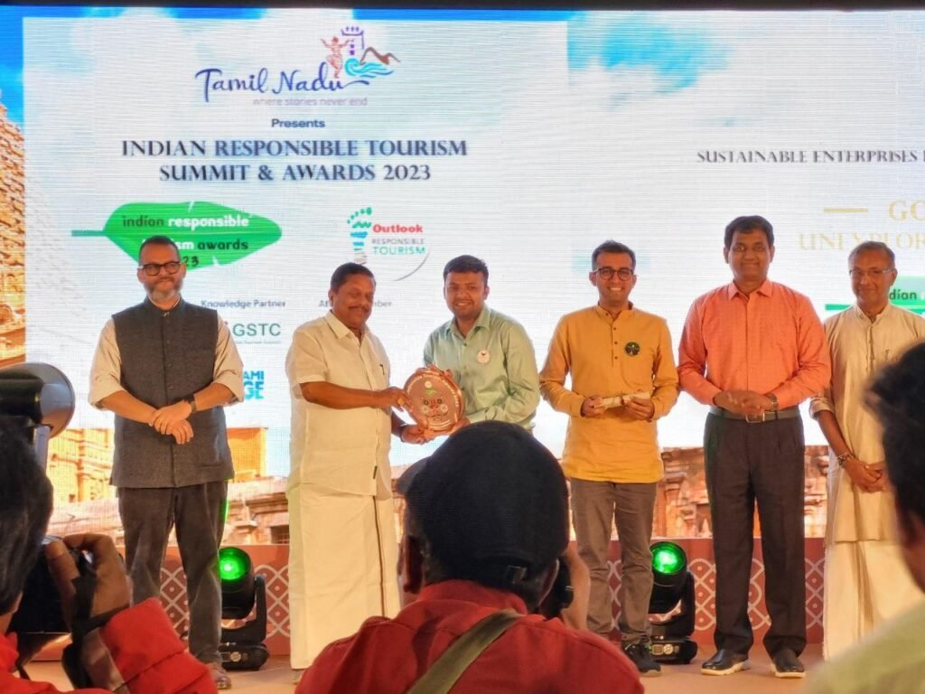

- Xen Farms - From NASA to the Soil: The IITian Who Came Back to Rebuild Indian Agriculture
XEN Farms was born from an unlikely journey—from the laboratories of advanced technology to the fields of rural India. Diptesh Mukherjee, an IIT Bombay Mechanical Engineering alumnus and son of a farming family, had built a career working on advanced technology projects in the US, including projects connected with NASA, and holds 20+ granted US patents. Yet, the problems he had seen in his family's agricultural roots stayed with him.
In 2019, Diptesh chose to return to rural India with a very different ambition: make farming profitable, productive and climate-resilient for small farmers. Together with serial entrepreneur Prantik Sinha, an engineering graduate with experience in climate action, aquaponics and renewable energy, and Sourav Patra, an agripreneur who has been working with agriculture since childhood, he built XEN Farms.
XEN combines natural farming, carbon-based agricultural inputs, technology and market access to help farmers increase productivity while rebuilding soil health. Its platform integrates crop advisory, farm monitoring, soil nutrition, finance and an agricultural marketplace, creating an end-to-end model rather than simply selling farmers another input.
The journey has attracted heavyweight institutional recognition: XEN has been supported/incubated by organisations including TISS, IRMA iSEED, Villgro, MANAGE-CIA and Stanford Seed Spark, and Diptesh was selected for Yale School of Management's Global Social Entrepreneurship programme. XEN also won the Stanford Seed Spark South East Asia 2022 programme.
More recently, XEN's growing impact has been recognised through the Janhit Jagran Social Impact Award 2025, with the company reported to be reaching 5,000+ farmers across 80 crops.
For TIF, XEN Farms is a remarkable example of what incubation can enable: bringing together frontier technology, entrepreneurial pedigree and lived understanding of rural India to tackle one of the country's most fundamental challenges—making farming both economically viable and environmentally sustainable.




- From a Skill to a Dream: Zahida’s Journey Towards Independence
For Zahida of Anantnag, tailoring began as a skill—and slowly became a pathway to independence. She first learned the craft at ITI Anantnag and later strengthened her skills as a trainer at the Skill Development Center.
But Zahida wanted more than employment; she wanted to build something of her own.
Starting from her home, she began offering tailoring services to women in her community.
With determination and enterprise, her home-based initiative grew into a boutique offering tailoring, cosmetics and accessories.
Today, the boutique provides Zahida with a steady source of income and helps support her family. But her ambition extends beyond her own livelihood. She sees her enterprise as a platform through which other women can find opportunity, confidence and economic independence.
Her plans include mentoring young women and expanding the business to create more opportunities.
For Zahidah, entrepreneurship is not simply about building a business—it is about stitching together a more empowered future for the women of Anantnag.
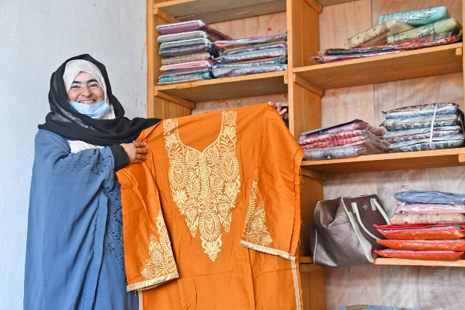

- ForschMedX - From an ICU Problem to a Global MedTech Innovation
ForschMedX, founded by Abhishek Gaikar, is tackling a problem that sits at the heart of intensive care: how to safely and consistently manage airway secretions in patients dependent on mechanical ventilation. What began as a clinically observed problem has evolved into TrachEase, an innovative system that combines a modified endotracheal tube with automated, sensor-enabled suctioning.
The ambition is significant: to reduce secretion build-up, lower the risk of ventilator-associated pneumonia, reduce the burden of repetitive manual suctioning for ICU staff, and provide more consistent airway care.
Gaikar, a pharmaceutical sciences professional and NIPER alumnus, has taken the idea from early innovation through clinical and engineering development. ForschMedX was part of the BIRAC SPARSH/SIIP ecosystem, where Gaikar received an Award of Excellence in 2023. The company has since been supported by multiple incubation ecosystems, including VJTI-TBI, Venture Center and CIIC.
The innovation has begun attracting recognition beyond incubation: TrachEase won India’s Best Design Project Award 2025, while ForschMedX was selected under the BIRAC BIG-24 programme for medical devices and diagnostics. The company has also secured a Startup Punjab Seed Fund grant to advance product development and validation.
Its intellectual-property journey is advancing as well, with an international patent application covering an automated system for airway secretion management and ventilation synchronisation.
For TIF, ForschMedX is a powerful example of incubation at the frontier of social impact: taking a real problem in critical care, combining science, engineering and clinical insight, and helping an early-stage idea move towards a technology with the potential to improve outcomes for some of the most vulnerable patients.
